Cinquain Poems

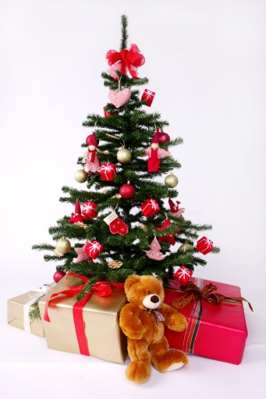
A cinquain is a five-line poem that uses adjectives, verbs and phrases to create an image of a person, place, or thing.

Christmas tree!
Red, Gold
Twinkling, sparkling, shining
What do you have for me?
Bearer of gifts!

Use this plan to write your own cinquain.
A word that tells what your poem is about (the subject of the poem)

Two adjectives associated with your subject (colours, smells, tastes, textures, qualities, etc)

Three verbs associated with your subject.
A sentence or phrase that tells us something else about your subject.

One or two words that relate to the subject of your poem (a synonym for the subject).

Follow this link for more information on writing cinquain poems
http://www.abcteach.com/free/h/howto_cinquain.pdf

